Often small conservation steps can make a huge difference. The importance of installing escape ramps in high desert watering troughs hit home to the district in a big way when the District Manager inspected a trough that did not have these ramps and found nearly twenty drowned chipmunks in the trough. While it was sad to see those cute little critters floating lifeless it could also create further trouble for the landowner when those bodies decay. Cattle will not want to drink water fouled with rotted rodents and there is potential for disease spread to livestock and wildlife both. And while it is sad to think about chipmunks, what if instead it had happened to an animal whose numbers are steadily shrinking?
The Harney Soil and Water Conservation District utilized funds from OrW Grant #21-05 to purchase an inventory of livestock ramps of varying sizes and shapes to mitigate such a risk in the future. These ramps are available to landowners for purchase now or will be incorporated into future projects.
Another such small step just completed is having an inventory of fence markers available to landowners to prevent birds from colliding into barbed wire fencing. Placing these markers will avoid unnecessary wildlife death from fence strikes and prevent fencing damage that could lead to cattle grazing where they shouldn’t.
Our goal is to have 100% participation from landowners and managers. The district considers these people partners in conserving the sage grouse and other wildlife. Contacting landowners to reveal these small steps will help them make their lands safe for animals and productive for cattle. The district further serves as a bridge between the landowner and government entities who fund these projects and previously may have been seen as an enemy.
The provided grant funds also helped stimulate the local economy. Fence markers were made at a local high school. This enabled students to gain work skills, hone ethics, and funded projects for them. The escape ramps were also fabricated locally. Knowing that the district supports local employers and projects also demonstrates to the landowners we are invested in a strong community.

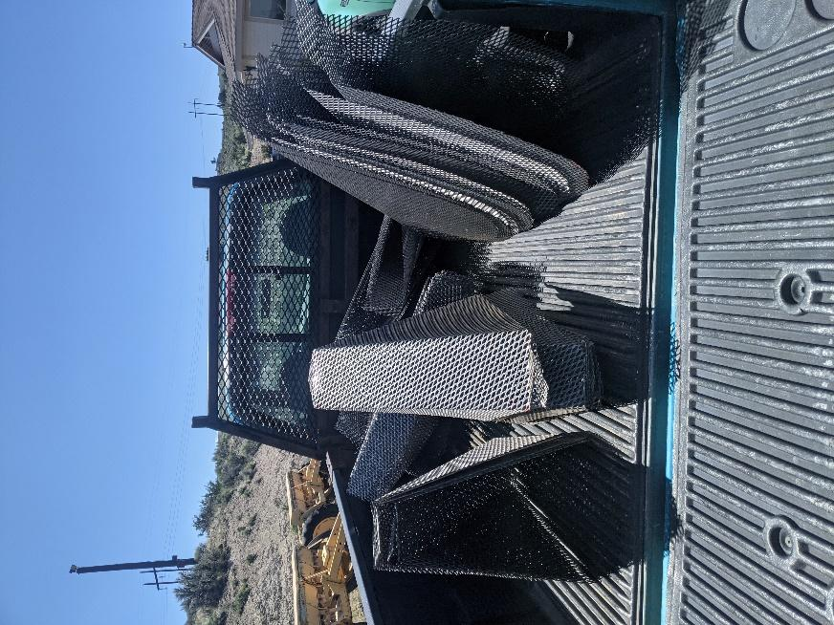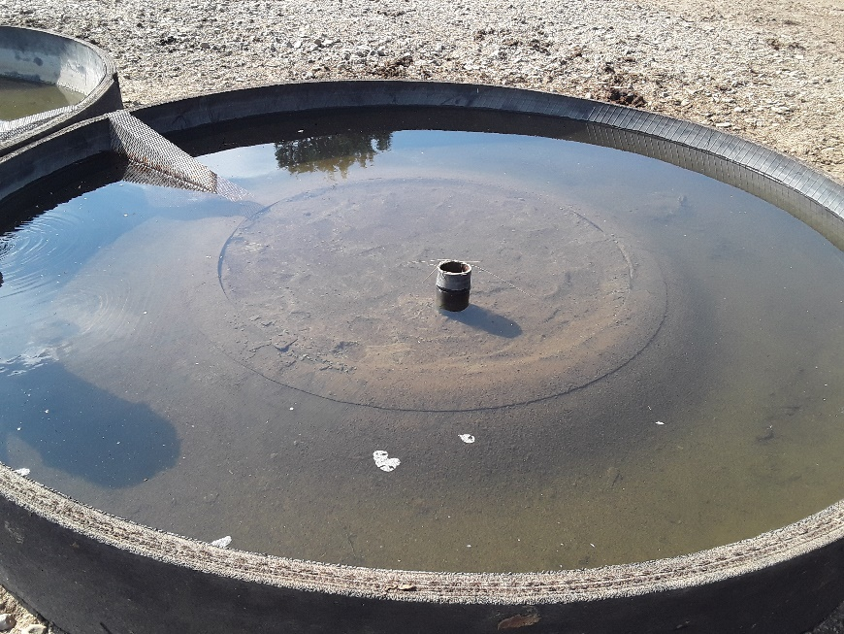
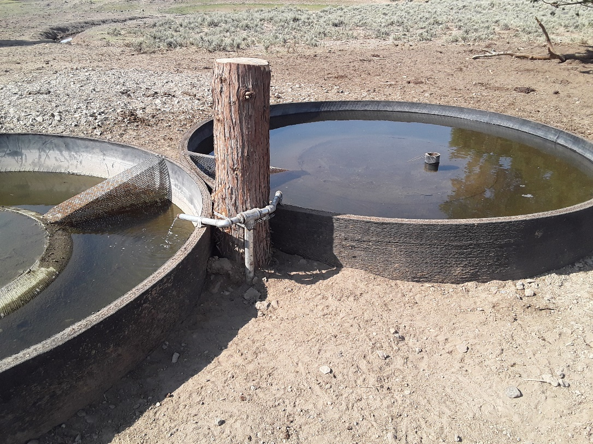
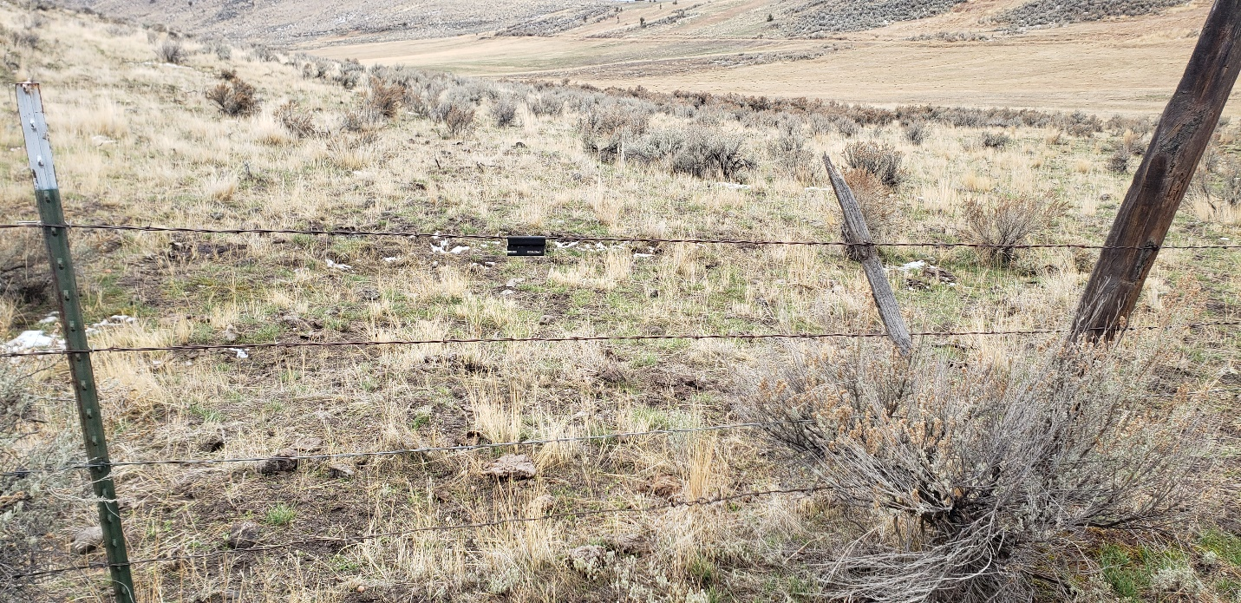

One of our volunteers marking the distance between fence markers and fence posts: | 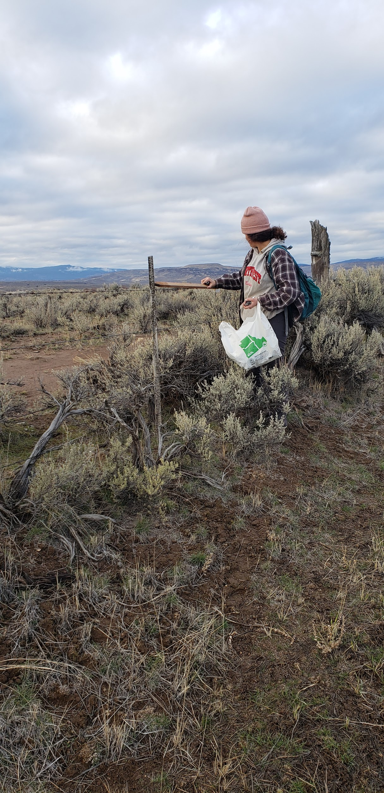
Here she is clipping markers to the fence: | 