17405 NE Glisan St., Portland, OR 97230

August 16, 2021

Sandy River Delta Oak Restoration Grant Report

Grant Agreement 20-21

Thanks to the Oregon Wildlife Foundation grant, we were able to continue our 5 year oak restoration project at the Sandy River Delta.

Despite Covid restrictions which resulted in Delta closures and being unable to utilize the talents of local students to plant the Oregon white oak seedlings, we were fortunate to have experienced Friends of Trees staff and volunteer leaders spend three days at the Delta and plant over 3,000 Oregon white oak seedlings. (See photographs 1,2)

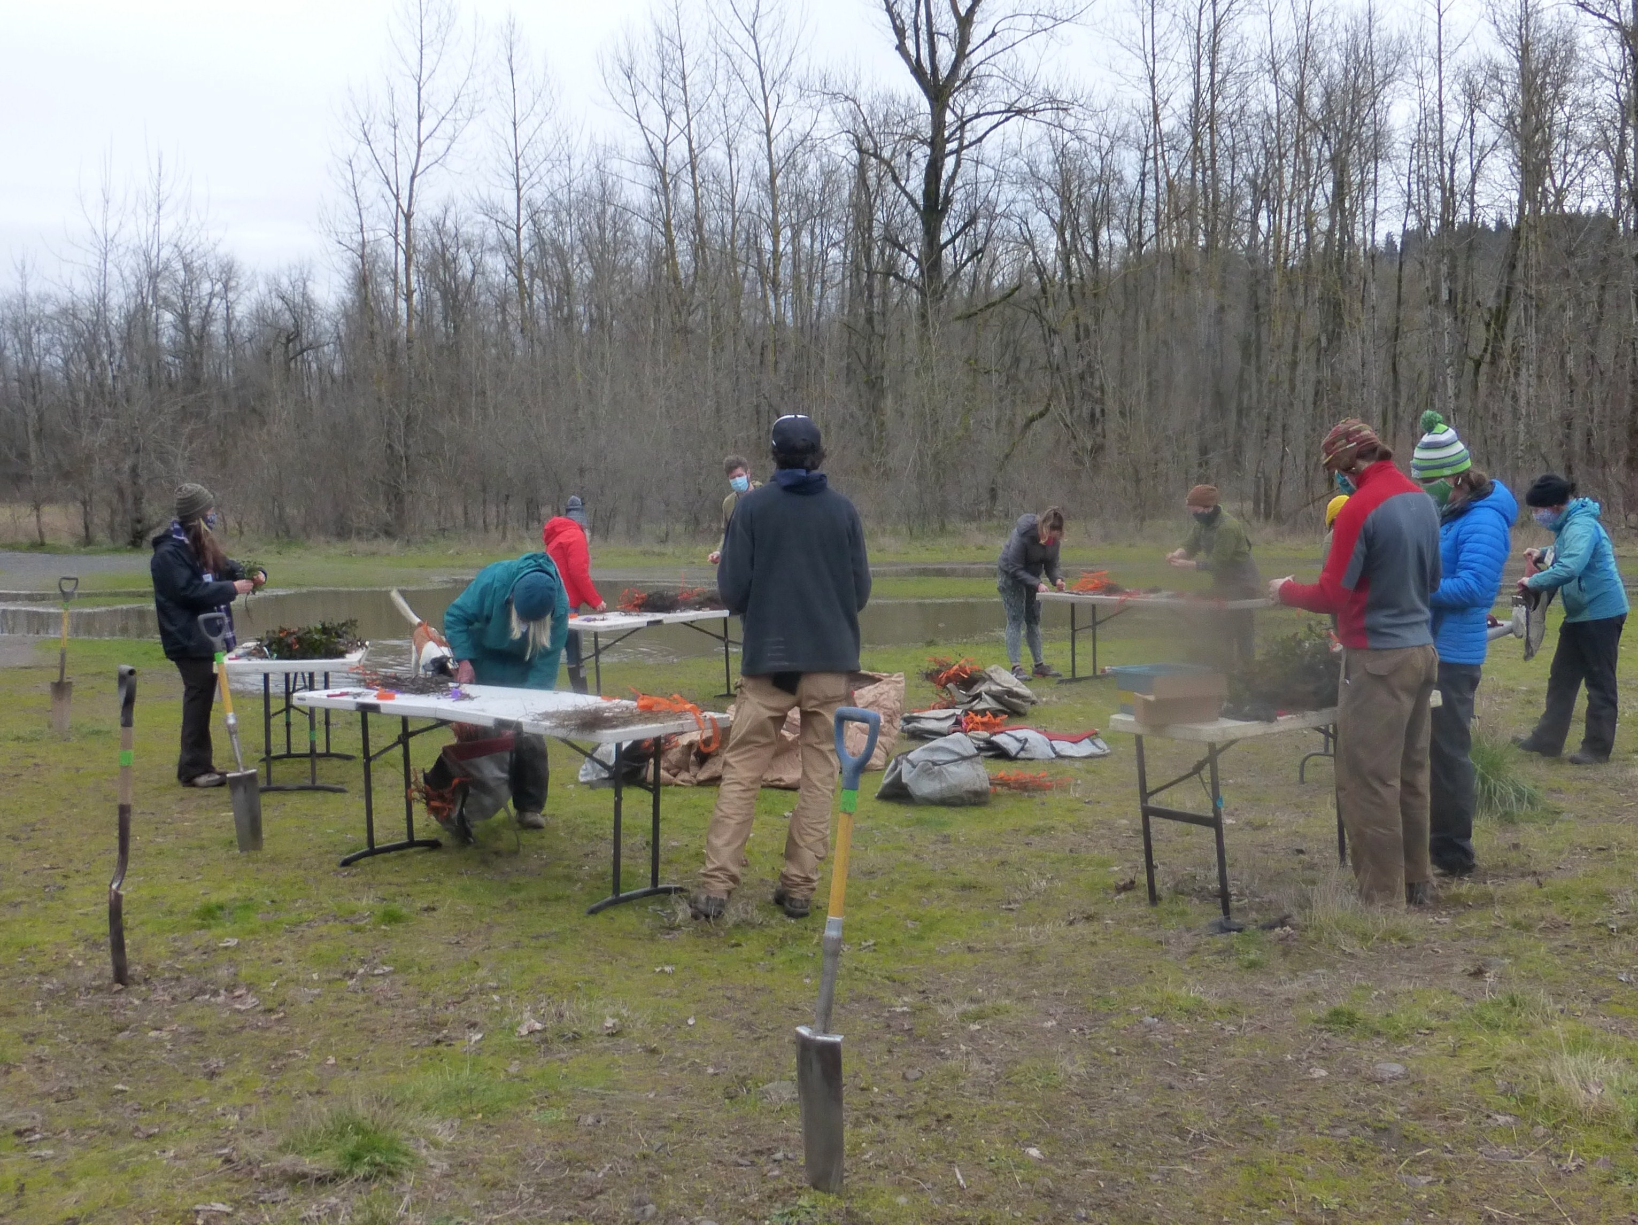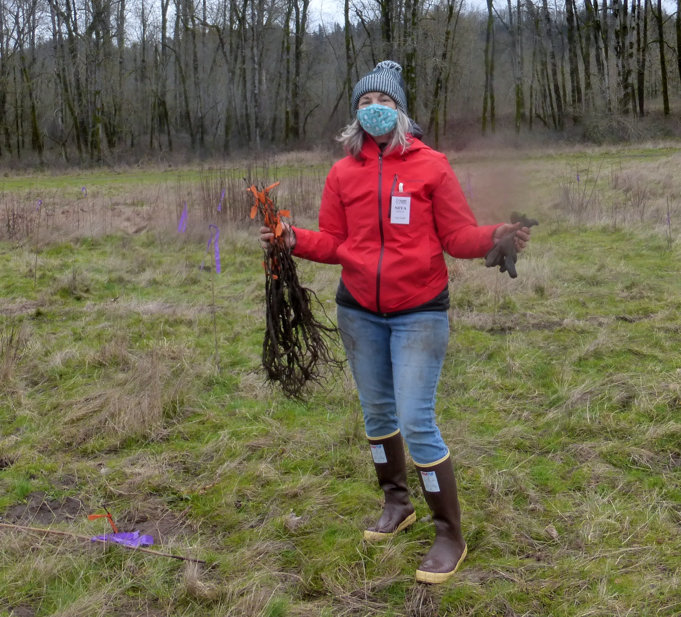
Photograph 1: February, 2021 Oak Planting Day Photograph 2: Oak bareroot seedlings

The major change to 2021 oak plantings involved using larger seedlings to insure planting success. Learning from installing larger cottonwood cuttings, we found that older, longer seedlings kept new plantings above the weeds and their roots better able to access water.

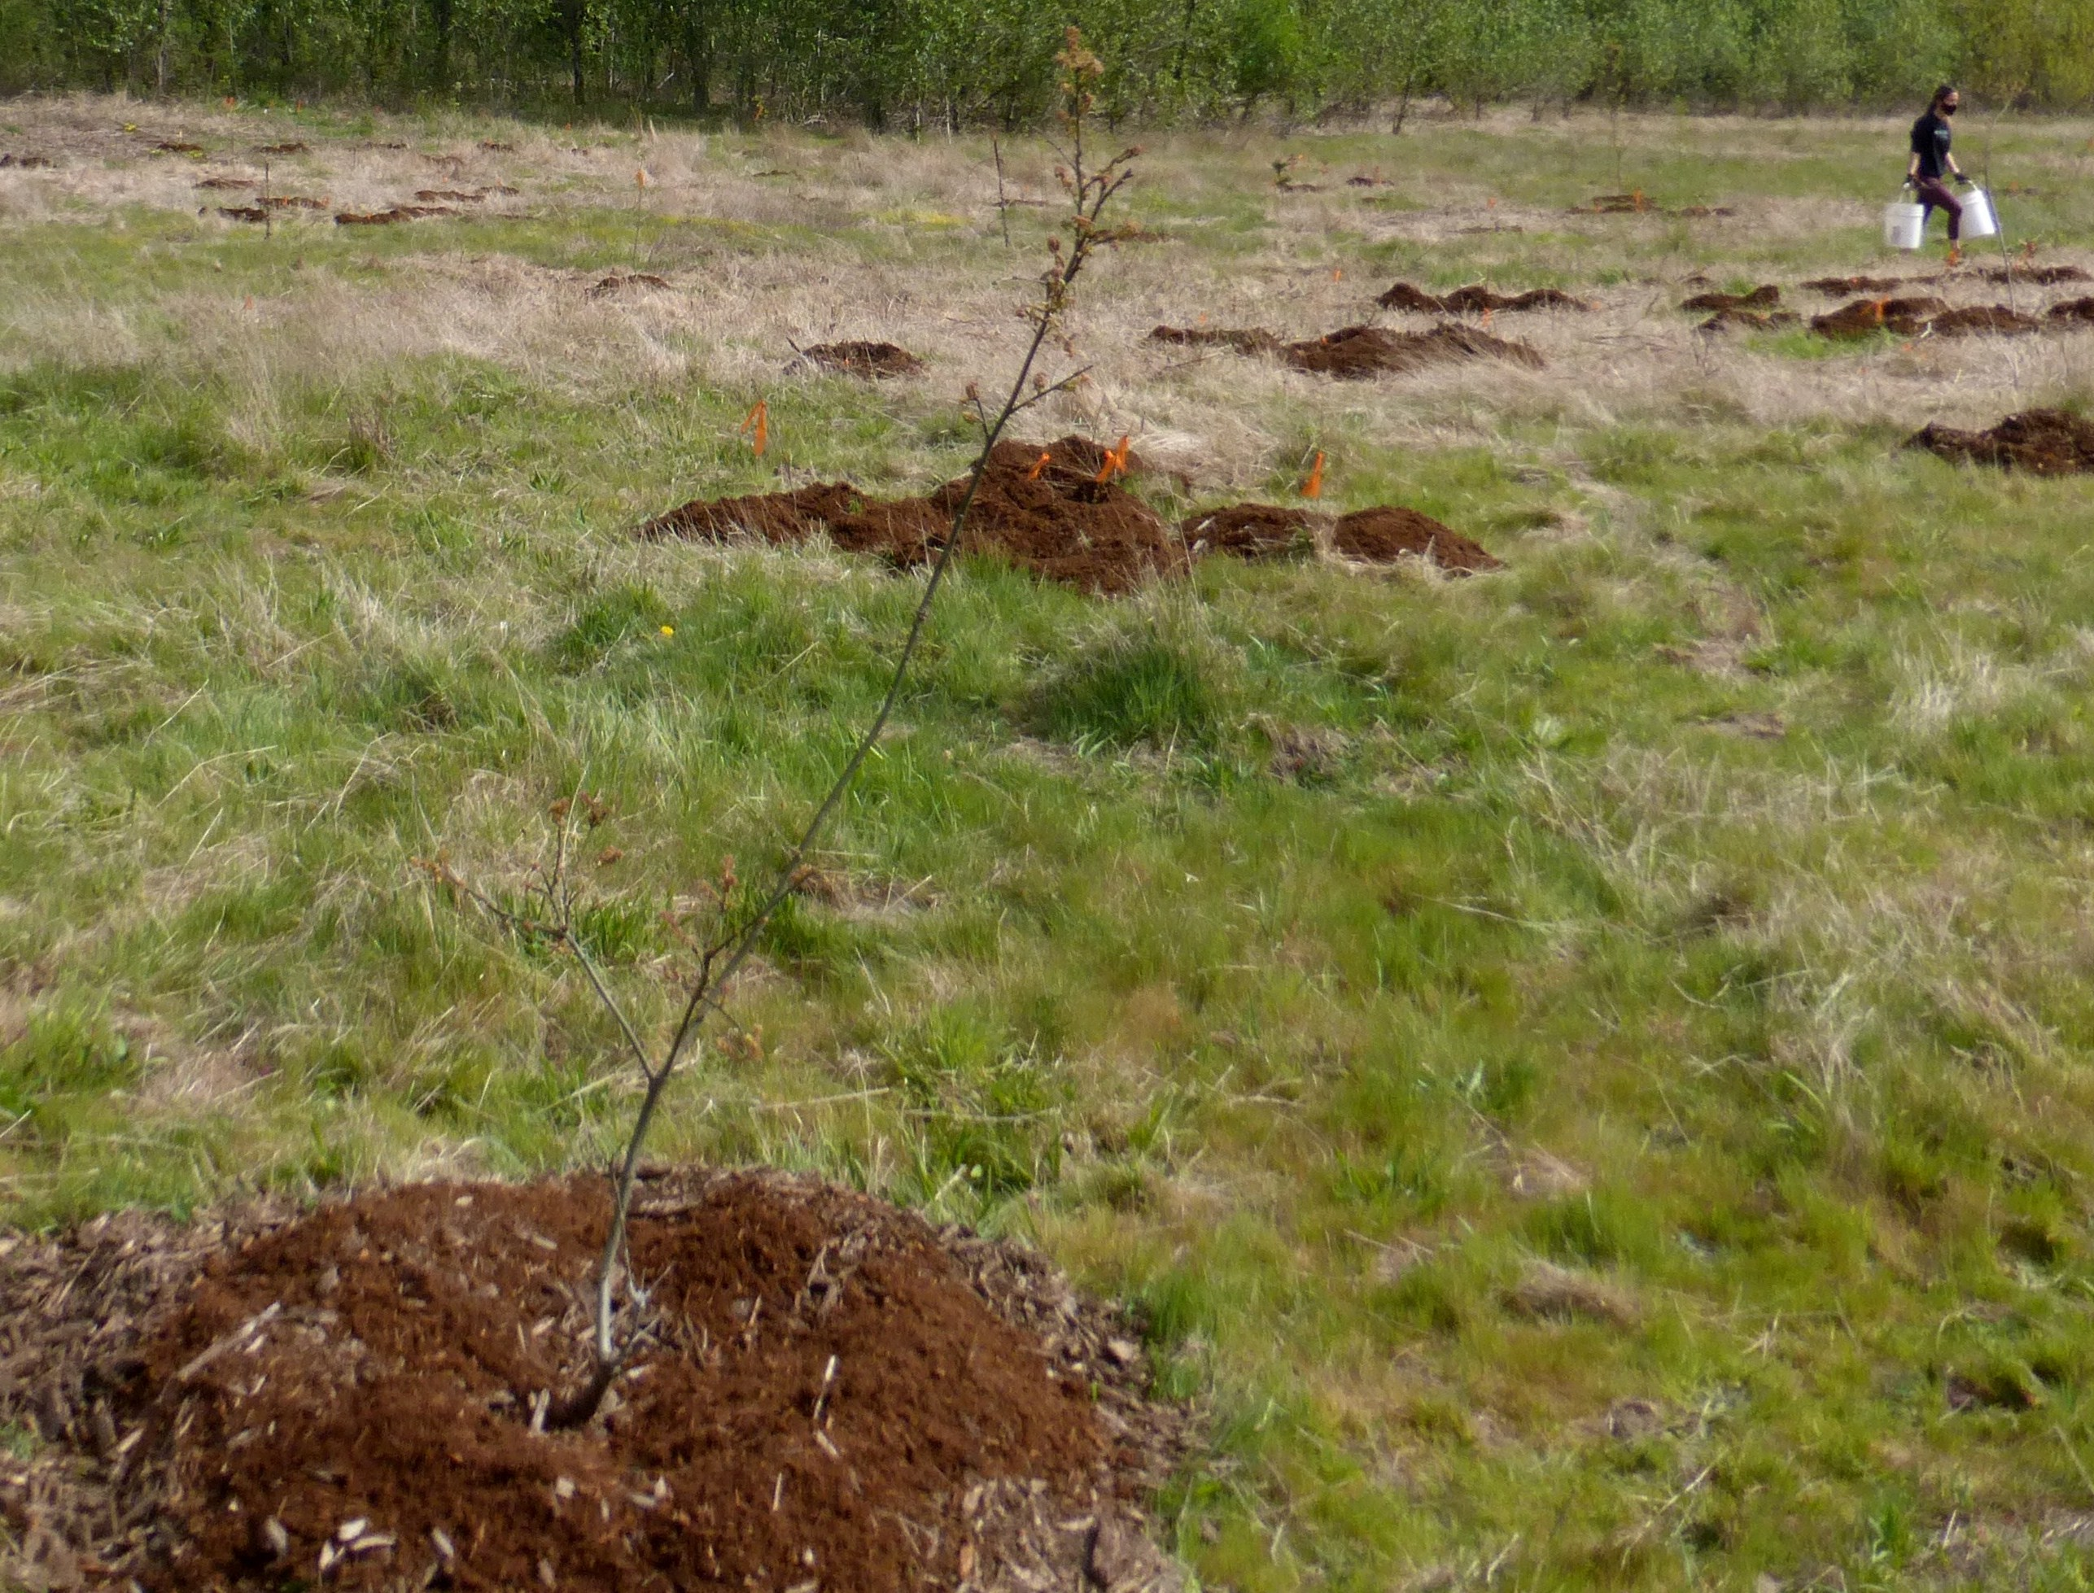
Photograph 3: Note larger, two year old oak seedlings

After planting, we are committed to five years of plant maintenance and monitoring, what we call plant establishment. We also mulched plants and thanks to a wonderful NW Youth Corps Crew, we removed invasive weeds around each oak plant.

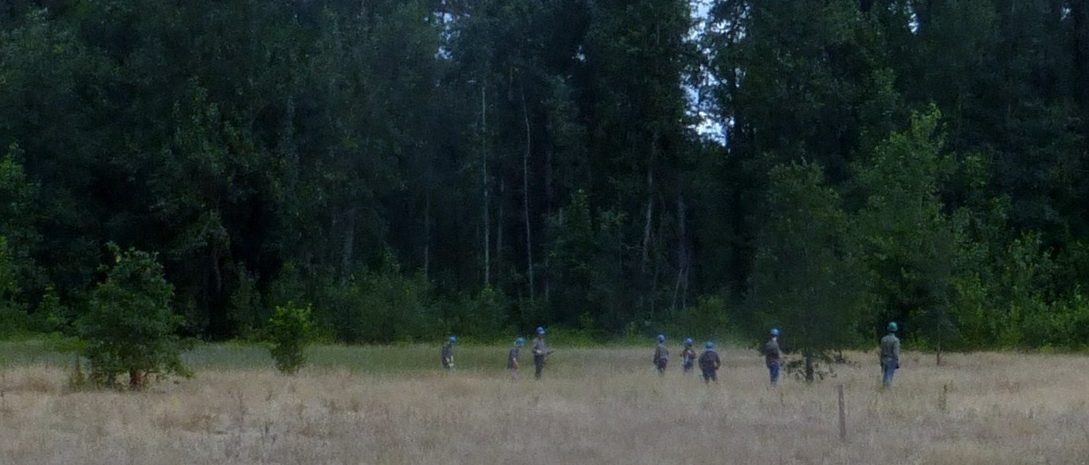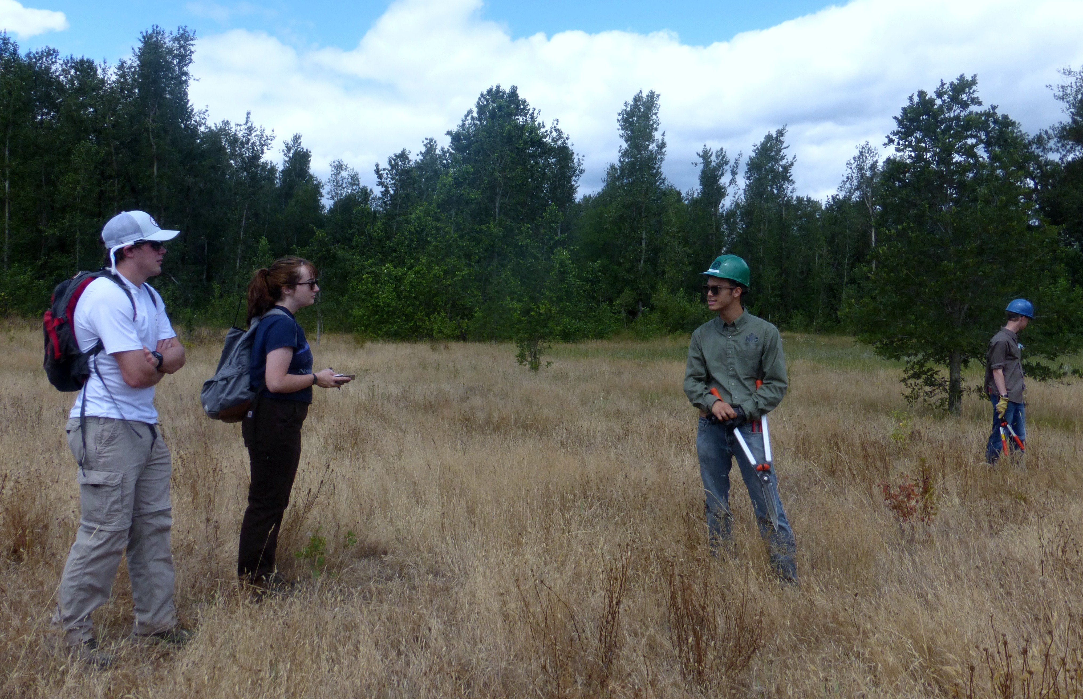
Photograph 4: NW Youth Corps Photograph 5: USFS Rangers and Youth Crew

We are crossing our fingers that local students will be able to return to the Delta to plant additional oak seedlings in 2022.

Thank you again for your support.

Sincerely,

Bill Weiler
Wildlife Biologist

